**Chapter 2**

**About the Department**

K-AKA Technology Services provided an internship in the department of software development and I have undergone the internship as Learning and designing the software. The objective was to derive multiple logic for the typical real-time challenges faced every day by a Software Engineer.

**2.1 Software Development Department**

The software development Process organizes practical procedures and approaches in application development. K-AKA Technology Service wants to streamline their internal departments and functions, operations, sale and project management, etc. and want to take the advantage of a web-based application, flexibility by moving away from the traditional desktop application platform to the web application platform and want to gain more client for better services their current clients offering convenient services and solutions online to build a new web application to offer innovative services or solutions to online user and business.

**2.1.1 Duties**

Software Developers typically do the following:

* Explore fundamental issues in computing and develop theories and models to address those issues.
* Help scientists and engineers solve complex computing problems.
* Invent new computing languages, tools, and methods to improve how people work with computers.
* Develop and improve the software systems that form the basis of the modern computing experience.
* Design experiments to test the operation of these software systems.
* Analyze the results of their experiments.
* Publish their findings in academic journals.

**2.2 Process Structure**

The following figure and list of procedures and documents provide a good outline for Lifecycle and Process:

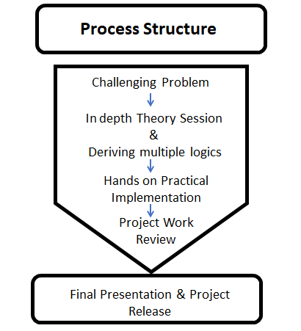

**Fig 2.1:** Process structure

**1. Challenging Problem: software developers**improve computer algorithms, which are sets of instructions that tell a computer what to do. Some computer tasks are very difficult and require complex algorithms. They try to simplify these algorithms to make computer systems as efficient as possible. These algorithms allow advancements in many types of technology, such as machine learning systems and cloud computing.

**2. In-depth Theory Session and Deriving Multiple Logics:**The work often leads to technological advancements and efficiencies, such as better networking technology, faster computing speeds, and improved information security, and deriving multiple logic for the given problem statement. In general, computer and information research scientists work on a more theoretical level than do other computer professionals.

**3. Hands-on Practical Implementation:**Computer and information research scientists design new programming languages that are used to write software. The new languages make software writing more efficient by improving an existing language, such as Java, or by making a specific aspect of programming, such as image processing, easier.

4.     **Project work review:**A Project Work Review is an exercise undertaken at the end of each Project Phase to identify the current status of the project. The Project Review identifies the deliverables which have been produced to date and determine whether or not the project has met the objectives set.

5.     **Final Presentation and Project Release:** The term release is used to define when a project deliverable is complete and ready for delivery to the project customer, either internally (to manufacturing or operations, for example) or to an external company or individual.

2.3 Software Development Process

     The following list of the procedures and documents provide a good outline for the software development and process:

· Roadmap document: Defining application, process, goal, and direction

· Researching and Defining Audience scope and security documents

· Creating Functional Specification or Feature Summary Documents

· Team Collaboration and project management document

· Application Visual Guide, design layout, interface design, wire framing

· Database structure design

· Testing: Quality Assurance, Multiple Browser Compatibilitys, Security, Performance- Load and Stress Testing, Usability

· Maintenance